# CS 255 Business Requirements Document Template

Complete this template by replacing the bracketed text with the relevant information.

This template lays out all the different sections that you need to complete for Project One. Each section has guiding questions to prompt your thinking. These questions are meant to guide your initial responses to each area. You are encouraged to go beyond these questions using what you have learned in your readings. You will need to continually reference the interview transcript as you work to make sure that you are addressing your client’s needs. There is no required length for the final document. Instead, the goal is to complete each section based on your client’s needs.

**Tip:** You should respond in a bulleted list for each section. This will make your thoughts easier to reference when you move into the design phase for Project Two. One starter bullet has been provided for you in each section, but you will need to add more.

## System Components and Design

### Purpose

*What is the purpose of this project? Who is the client and what do they want their system to be able to do?*

* The client is DriverPass
* They want to build an application that provides training for students who are taking their driving test at the local DMV.
* The application will provide online classes, practice tests, and on-the-road training for those who wish to avail of it.

### System Background

*What does DriverPass want the system to do? What is the problem they want to fix? What are the different components needed for this system?*

* They want to access data online from any computer or mobile device.
* They want this system to work both offline and online.
* Data is stored only when the application is being used online.
* They want a system with different levels of security and user roles.
* They want the capabilities to download data.

### Objectives and Goals

*What should this system be able to do when it is completed? What measurable tasks need to be included in the system design to achieve this?*

* The design needs to match the specifications in the drawing provided by Liam. Therefore, the following components of the system must be included and functional:
  + A list of the tests that the student has taken or is currently taking, including the following details: name of the test, time taken, score, and status (taken, in progress, failed, or passed).
  + Notes from the driving instructor with the following details: lesson time, start hour, end hour, driver comments.
  + The students' information (first name, last name, city, state, zip code, email, etc.)
  + A list of the student's special needs
  + A picture of the driver and the student
* There should be a page where a secretary can input the student's information (first name, last name, city, state, zip code, email, etc.). Additionally, there should be a page where the student can contact us, and we can also get in touch with the student.
* We need a page and functionality where the user can select a driving package. On this page, we should advise the potential students to call us to register. When they call us, we will collect their information, including first name, last name, address, phone number, state, as well as their credit card number, expiration date, and security code.
* This is preferably a web-based application and uses the cloud because they do not want to deal with backups and security.

## Requirements

### Nonfunctional Requirements

*In this section, you will detail the different nonfunctional requirements for the DriverPass system. You will need to think about the different things that the system needs to function properly.*

#### Performance Requirements

*What environments (web-based, application, etc.) does this system need to run in? How fast should the system run? How often should the system be updated?*

* This should be a web-based application with offline capabilities
* The cloud system we select should be regularly updated with the latest version of the software to avoid any bugs and vulnerabilities.
* They mentioned that they want to focus on the business and have all technical aspects handled for them. This means we need to maintain the systems the application runs on and the services the application uses..

#### Platform Constraints

*What platforms (Windows, Unix, etc.) should the system run on? Does the back end require any tools, such as a database, to support this application?*

* Since this is a web-based application, it should function properly on all browsers across different operating systems.
* The cloud service we select should also provide us with a database to store student and driver data. Additionally, we should have the capability to back up that database on a daily basis.

#### Accuracy and Precision

*How will you distinguish between different users?* *Is the input case-sensitive? When should the system inform the admin of a problem?*

* The system needs to have the capability to distinguish between different roles and permissions based on the users' email addresses. If the user enters a Driver Pass work email, they will have some level of admin access. Otherwise, they will be considered a customer/student.
* The system is case-sensitive, and we cannot have duplicate email addresses.

#### Adaptability

*Can you make changes to the user (add/remove/modify) without changing code? How will the system adapt to platform updates? What type of access does the IT admin need?*

* The system should possess the capabilities for administrators to input, modify, or remove user information without requiring any code changes.
* However, the system will not have the capability for custom modules. This is a feature we will develop after the initial system is launched.
* The IT admin will have full-level access to the system so that we can maintain the overall health of the application and develop, modify, or add new features.

#### Security

*What is required for the user to log in? How can you secure the connection or the data exchange between the client and the server? What should happen to the account if there is a “brute force” hacking attempt? What happens if the user forgets their password?*

* The user needs to register an account with the system by providing an email and creating a password.
* The user is given 10 tries to enter their credentials. If there is an issue, an email will automatically be sent to the admin. If the user selects "Forgot Password," they will be given a link to reset their password. In this case, the admin will also be notified.
* The system should adhere to the latest security standards for all form inputs. We need to safeguard the system against SQL injections and CSRF attacks.

### Functional Requirements

*Using the information from the scenario, think about the different functions the system needs to provide. Each of your bullets should start with “The system shall . . .” For example, one functional requirement might be, “The system shall validate user credentials when logging in.”*

* The system shall authenticate the user based on email and password
* The system shall show details about the student’s progress on the different driving tests
* The system shall show the notes taken about the student from the driver
* The system shall allow admins to create,edit, and delete student/customer profiles
* The system shall save the details regarding package the student has registered
* The system shall display the 3 available packages. Unless the package has been disabled.
* The system shall provide a way for customers to communicate with the driver and designated employees and DriverPass.
* The system shall confirm the student/customers’ personal and contact details

### User Interface

*What are the needs of the interface? Who are the different users for this interface? What will each user need to be able to do through the interface? How will the user interact with the interface (mobile, browser, etc.)?*

* The user interface needs to be visually appealing to the students/customers. We are displaying information such as test status and progress, so they should be presented in the form of progress bars and charts. Moreover, images of the driver and student are being displayed, hence they must be clear and not pixelated. Additionally, since customers/students might also use the application on mobile devices, it should be made mobile-responsive.
* The user interface needs to be made more functional for employees. They should be able to manage customer data and perform various administrative tasks. Therefore, it is important to design the UI in a way that facilitates easy completion of work tasks for employees.

### Assumptions

*What things were not specifically addressed in your design above? What assumptions are you making in your design about the users or the technology they have?*

* The systems needs a homepage
* An about page
* An admin portal where an employee can manage student/customer data
* Detail pages for each driving test
* Detail pages for any local DMV related information
* A profile page about each driving instructor

### Limitations

*Any system you build will naturally have limitations. What limitations do you see in your system design? What limitations do you have as far as resources, time, budget, or technology?*

* Everything from a business and timeline perspective has been laid out clearly. However, there are limitations in terms of time and technology. We would need to research the best software tools and cloud providers based on their business needs. Cloud providers are often costly, and we would need to present these costs to the business before proceeding.

### Gantt Chart

*Please include a screenshot of the GANTT chart that you created with Lucidchart. Be sure to check that it meets the plan described by the characters in the interview.*

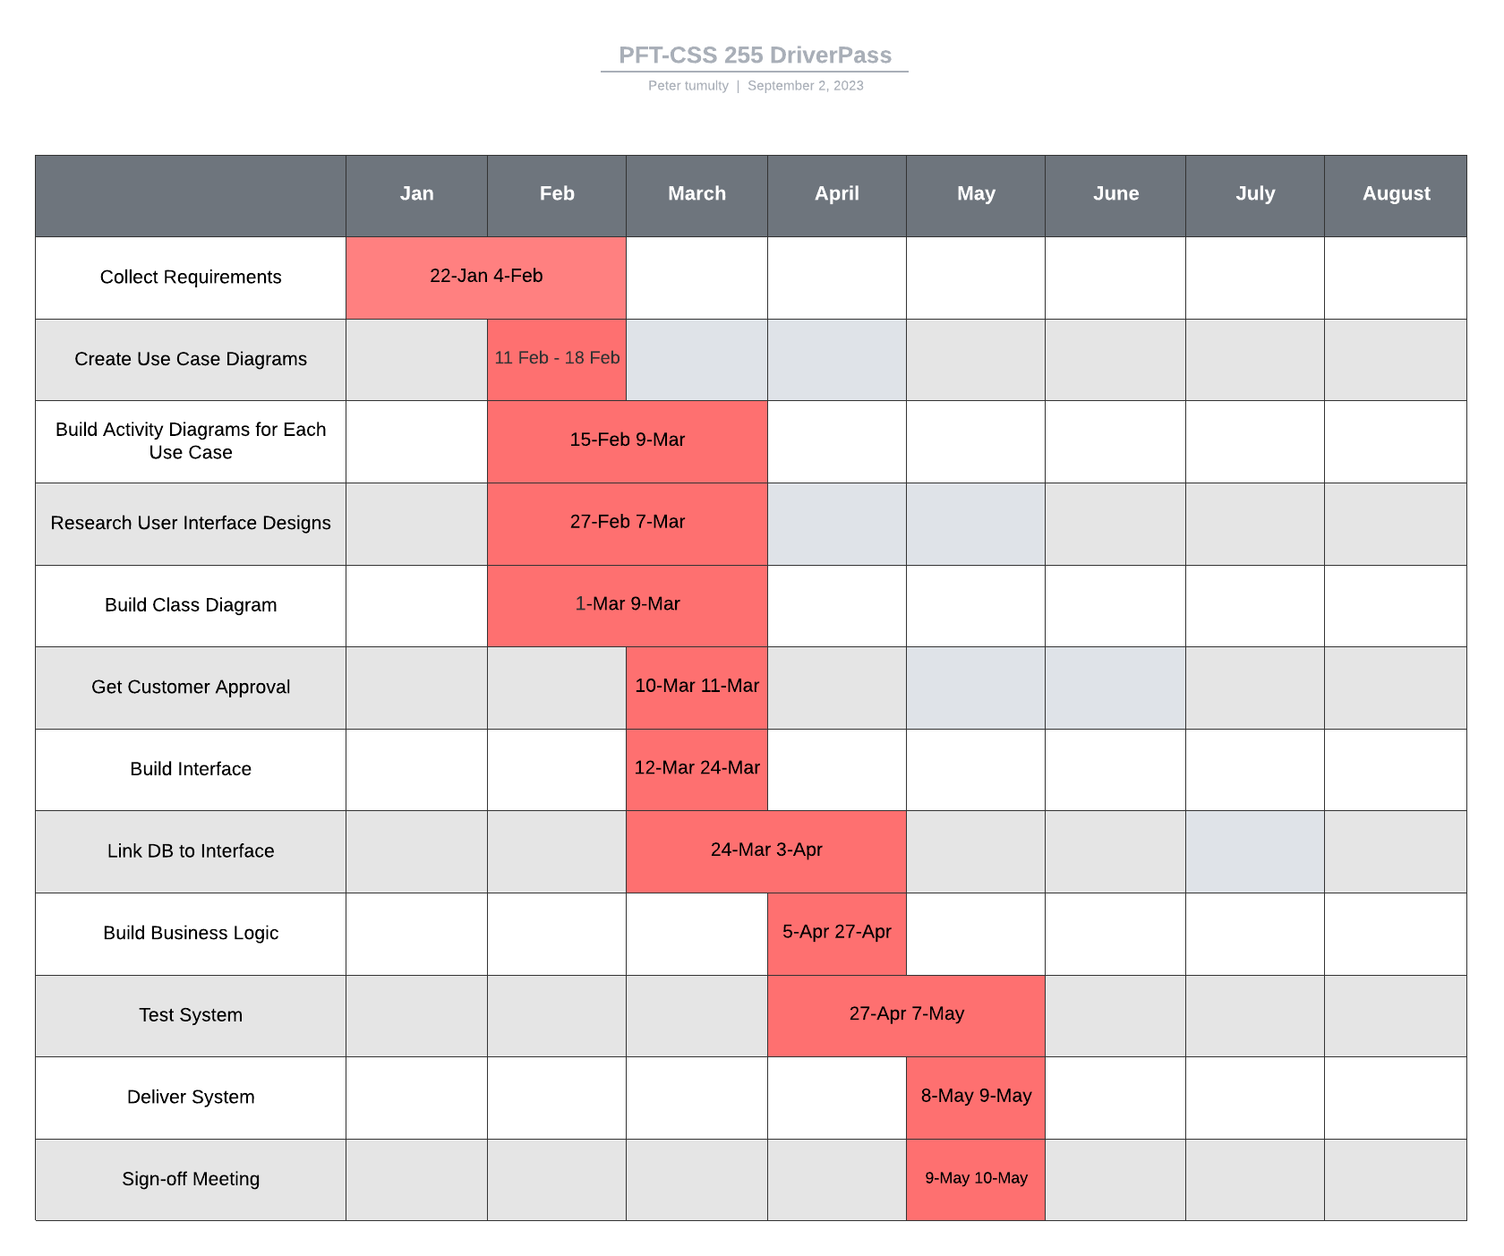

### UML Case Diagram

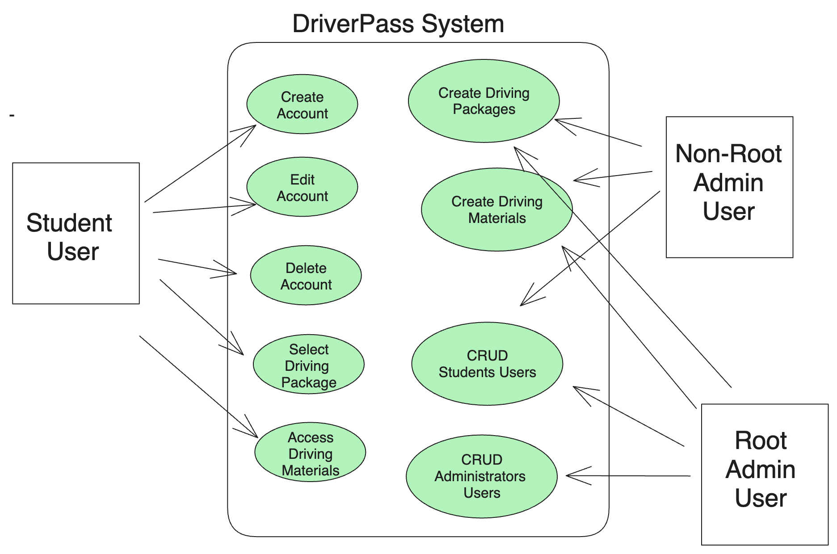

### Student UML Activity Diagram

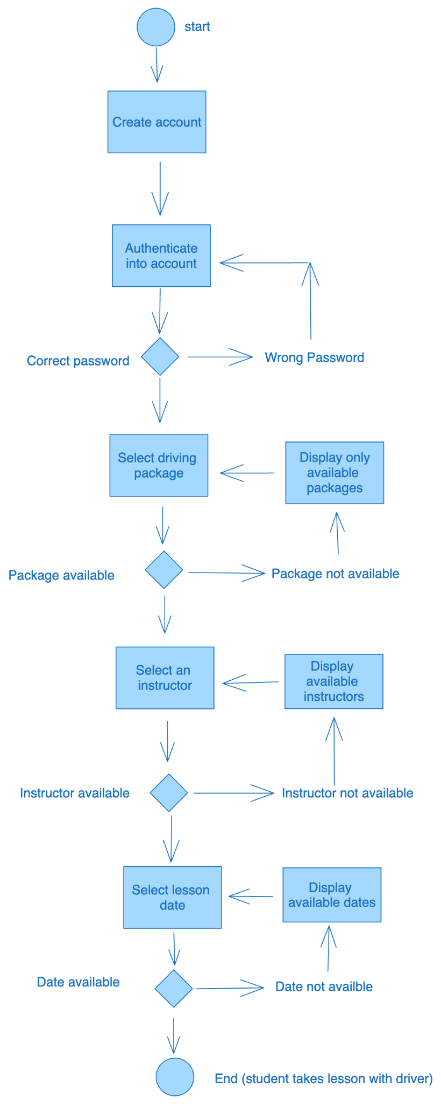

### Employee UML Activity Diagram

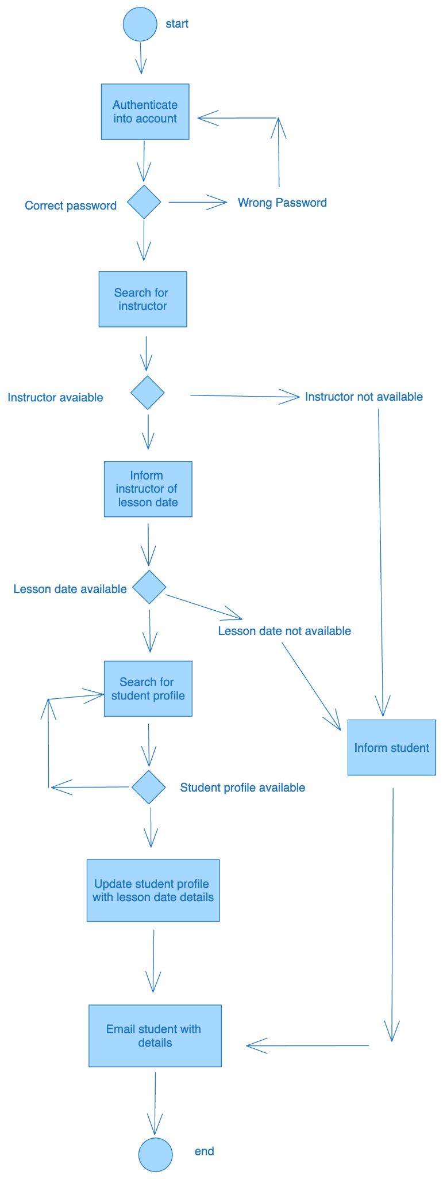

### UML Sequence Diagram

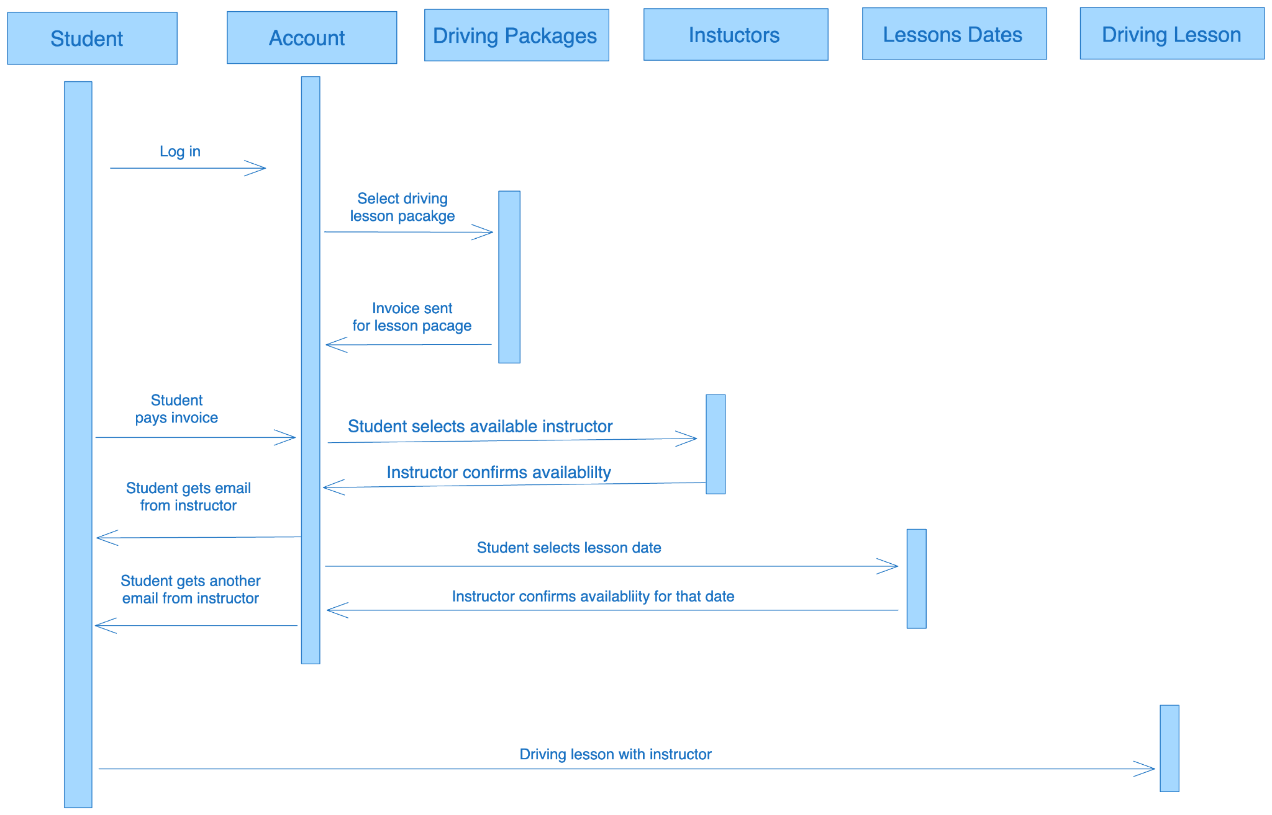

### UML Class Diagram

